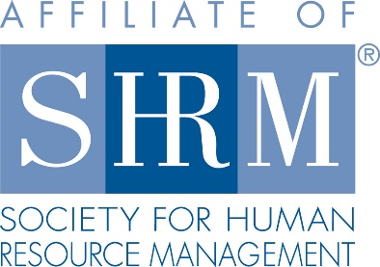 | Helena SHRM  Board Meeting Minutes  Overland Express  11:30 – 12:30  September 8, 2022 | 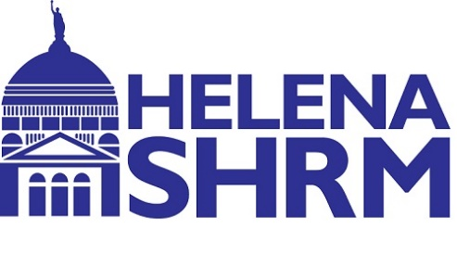

- Attendees: Heather Rankin, Karol Anne Davis, Todd Jackson, Joanna Halland, Michelle Edmunds, Sarah Peters, John Pavao, Renee Wooster, Tiffany Thornton, Dawn Lambert, and Teresa Adams
- Absent: Mike Worden, Rebecca Bruno
  - Need a minimum of 8 out of the 15 to make a quorum
- Icebreaker: Labor Day weekend plans
- Approve Meeting Minutes: Joanna motioned to pass August Meeting minutes, Karol Anne seconded, all in favor and none-opposed.

- Treasurer (Sarah Peters):
  - Checking Balance $13,960.50
  - DA Davidson Balance – 7,334.80 around there
    - Please get Sarah receipts as soon as possible to be sure that everything is accounted for timely.
    - All purchase request needs to go to Sarah, and she will order the items. This will ensure everything is account for. If Sarah is unavailable and we need to order something ASAP board members can order it but need to get Sarah the receipts right away if they used a SHRM bank card or need to be reimbursed.
    - We will start sending the detailed budget excel sheet with the board meeting agendas for each board meeting.

- President (Karol Anne Davis)
  - Board Roles
  - Introductions for Interim Board Members
  - Board Elections
    - Will be held in October and announced in November.
    - If those in interim roles are interested in continuing their positions, they will be placed on the ballot.
    - Roles up for election:
      - Membership Director
      - Certification Director
      - Programs Director
      - Communications Director
      - Diversity Director
      - Workforce Readiness Director

  - HR Leader of the Year
    - Will start promoting early October.
    - Submission deadline will be the end of October.
    - Vote will be the beginning of November.
    - Will announce the winner at our December Holiday Social.
  - Chapter Meeting Next Week
    - Lunch Order – Sarah
    - Equipment (laptop and OWL) – John Pavao
    - Announcements – Dawn Lambert
    - Speaker Introduction – John Pavao
    - Logging in as SHRM to Zoom – John Pavao
    - Certification is already done.
  - Equipment
    - New laptop arrived.
    - We need to load programs and setup password.
  - State Council Update
    - Volunteer Leaders’ Business Meeting – November in DC
    - Helena is the host chapter for the 2023 State SHRM Conference in Billings
      - We will be in charge of registration, the welcome, and the entertainment for the Thursday night social.
  - Please try to show up to board and chapter meetings in person if possible to help the board reconnect. We still will have the hybrid options.

- President Elect (Dawn Lambert)

- Secretary update (Michelle Edmunds)

  - Brewhouse and L&C rooms are reserved for Dec 8th. Others please bring other location ideas for vote on location.
  - Everyone please bring location and time ideas for 2023 board meetings

- Membership Update (Amanda Yocom)

- Programs Update (John Pavao)
  - Current Line Up of Events (all presenters will be in person):
    - September – Economic & workforce Trends in Montana – Barb Wagner (Chief Economist, DLI)
    - October – Job Accommodation Network – Complex Accommodation Issues
    - November – Veterans Update – Nick Moschetti (Veterans Service Manager, DLI)
    - December – Social reserved December 8

- Foundation Update (Tiffany Thornton)

- Legislative Update (Mike Worden)

- Communications Update (Teresa Adams)

- Certification Update (Joanna Halland)

- Diversity Update (Shannin Danko)

- Social Media Update (Rebecca Bruno)

- Workforce Readiness Update (Renee Wooster)

- College Relations Update (Heather Rankin)

- AV/Webmaster Update (Todd Jackson)

- Motion to Close Meeting

  - Motion made by John to close meeting at 12:21pm, Joanna seconded, all in favor and none opposed.

2022 Monthly Chapter Meeting Calendar – 3rd Thursday of every month 11:30-12:30pm via online or at TBD

Month | Topic | Speaker(s)
January 20 | Supporting Caregivers in the Workplace | LaDawn Whiteside | AARP
February 17 | MARIJUANA AND THE WORKPLACE
March 17 | RQ – Results Through Relationship Intelligence | Michael Brown & Kyle Menig | Core strengths
April 21 | HUMAN RESOURCE MANAGEMENT AND THE RACI MODEL
May 19 | The Next Play Accountability System | Richie Contartesi | Author
June 24 | Why does your workplace need “Civility” | Jason Slead | Department of Revenue
July 15 | TBD
August | Top 8 HR Issues Under the Big Sky! | Michelle Edmunds/Corinne Moore | Westaff
September | Economic & workforce Trends in Montana | Barb Wagner | DLI
October | Complex Accommodation Issues | Lisa Mathess | Job Accommodation Network
November | Veterans Update | Nick Moschetti | DLI
December | Holiday Social

2022 Board:
- President: Karol Anne Davis (2nd year)
- Past President: Vacant/Karol Anne in 2023
- President Elect: Dawn Lambert (1st year)
- Treasurer: Sarah Peters (1st year)
- Secretary: Michelle Edmunds (1st year)
- Membership Director: Amanda Yocom (2nd year)
- Certification Director: Joanna Halland (2nd year)
- Programs Director: John Pavao (2nd year)
- Legislative Director: Mike Worden (re-elected 1st year)
- Foundations Director: Tiffany Thornton (1st year)
- Workforce Readiness Director: Renee Wooster (Interim until 12/31/2022)
- Communications Director: Teresa Adams (Interim until 12/31/2022)
- Social Media Director: Rebecca Bruno (1st year)
- Diversity Director: Shannin Danko (Interim until 12/31/2022)
- College Relations Director: Heather Rankin (2nd year)
- AV/Webmaster Director: Todd Jackson

